# Table of contents

Table of contents 1

Download installation files 2

Download TIBCO specific software 2

Download and Install SQL Developer: 7

Download and Install SQLPLUS 9

Configuration Metadata DB 12

Configure and Run Oracle RDS Database Script 12

Install Spotfire Server 15

Spotfire Configuration 18

Node manager installation 27

Run Node Manager setup 28

Trusting a node 31

Installing Spotfire Web Player instances 32

Installing Spotfire Automation Services 33

Installing TERR and Python Service 34

Installing Spotfire Analyst 37

Additional TERR Configuration 39

Setup Snowflake Datasource 41

# Download installation files

##### Download TIBCO specific software

1. Login to TIBCO edelivery website:

<https://edelivery.tibco.com/storefront/index.ep>

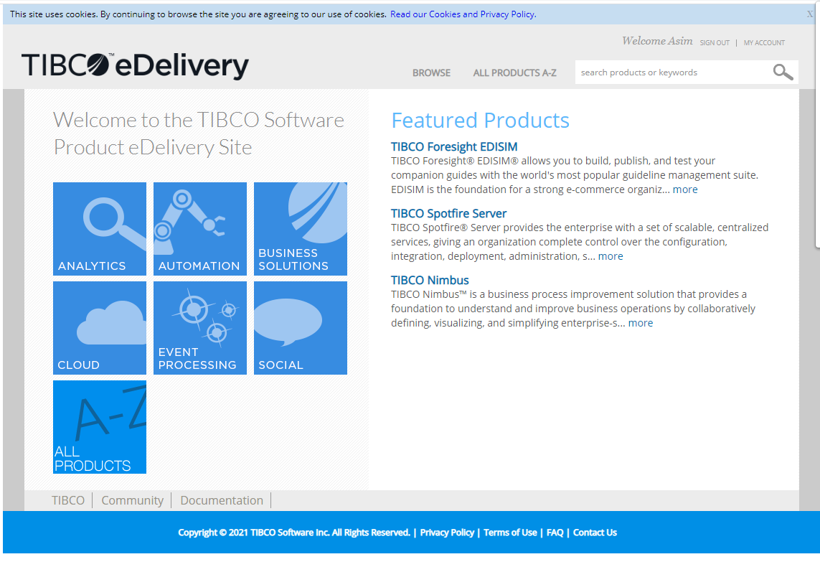

1. Click on TIBCO Spotfire Server -> Download
2. Select Platform as "Windows", check the license agreement and select "Full Product Download"

Refer to below screenshot:

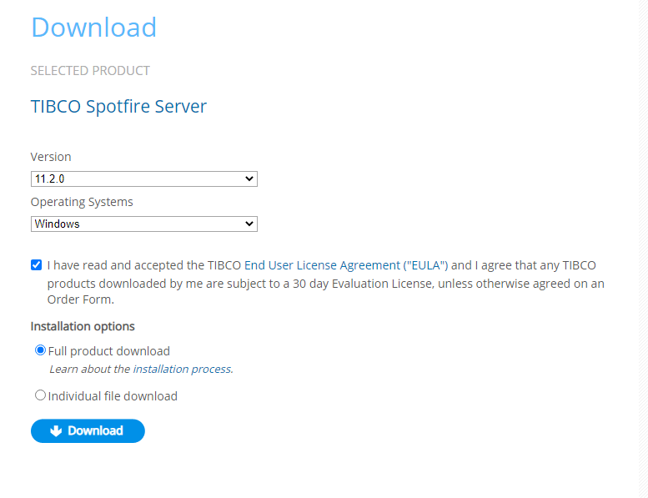

1. Click "Download" and then "Get Downloader".
2. Run the downloaded .exe file and it will start downloading all software components of the Spotfire server. Make a note of the folder in which downloader will be saving all files. :

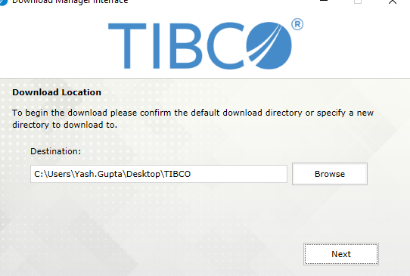

1. Repeat steps 2 – 5 for TIBCO Spotfire Analyst download :

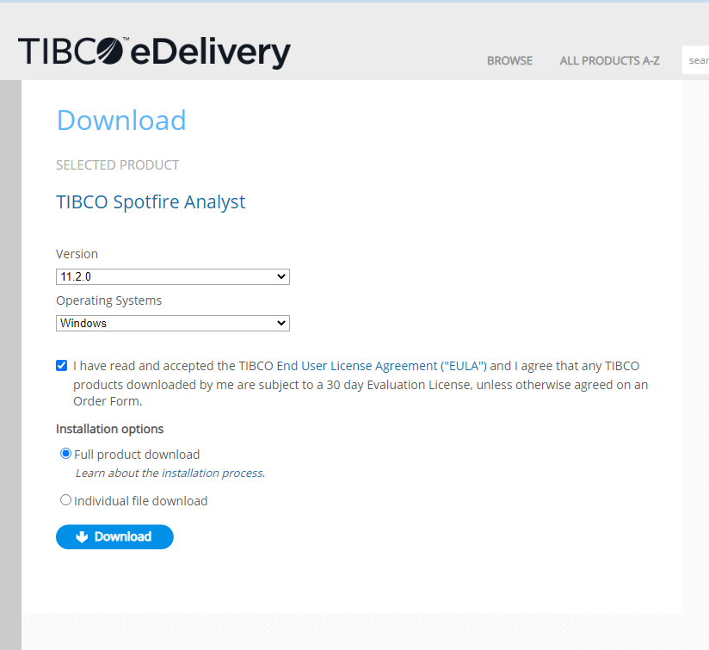

1. Move the folder to a generic location:

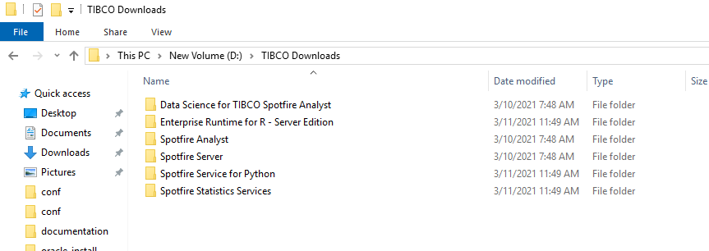

1. Download Deployment packages for TERR and Python

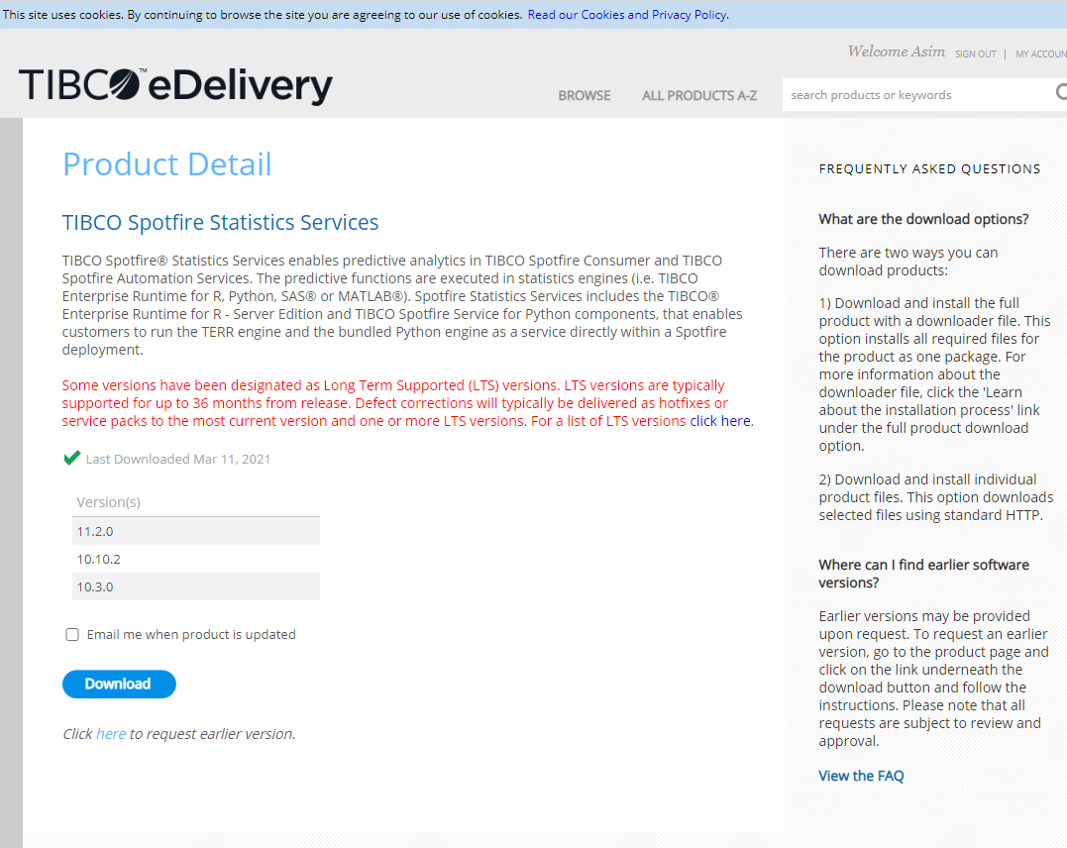

1. Move to downloads folder:

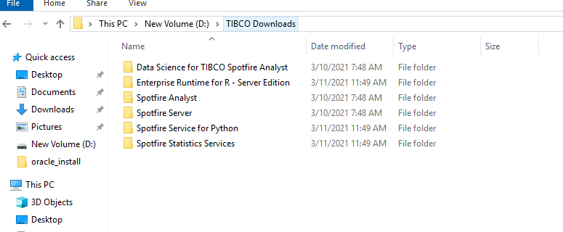

Below is the architecture for Spotfire setup:

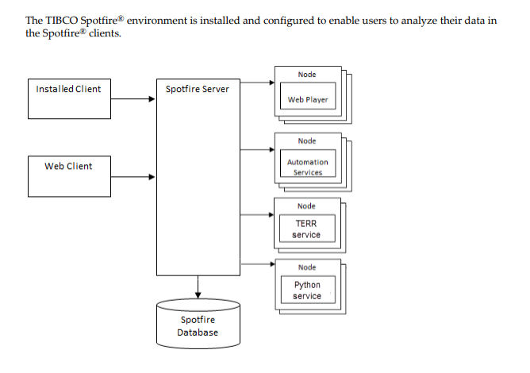

1. Download hotfixes, if any , from support site:

<https://support.tibco.com/s/hotfixes>

In our case, we are working with the latest version 11.2 and there are no hotfixes available for upgrade

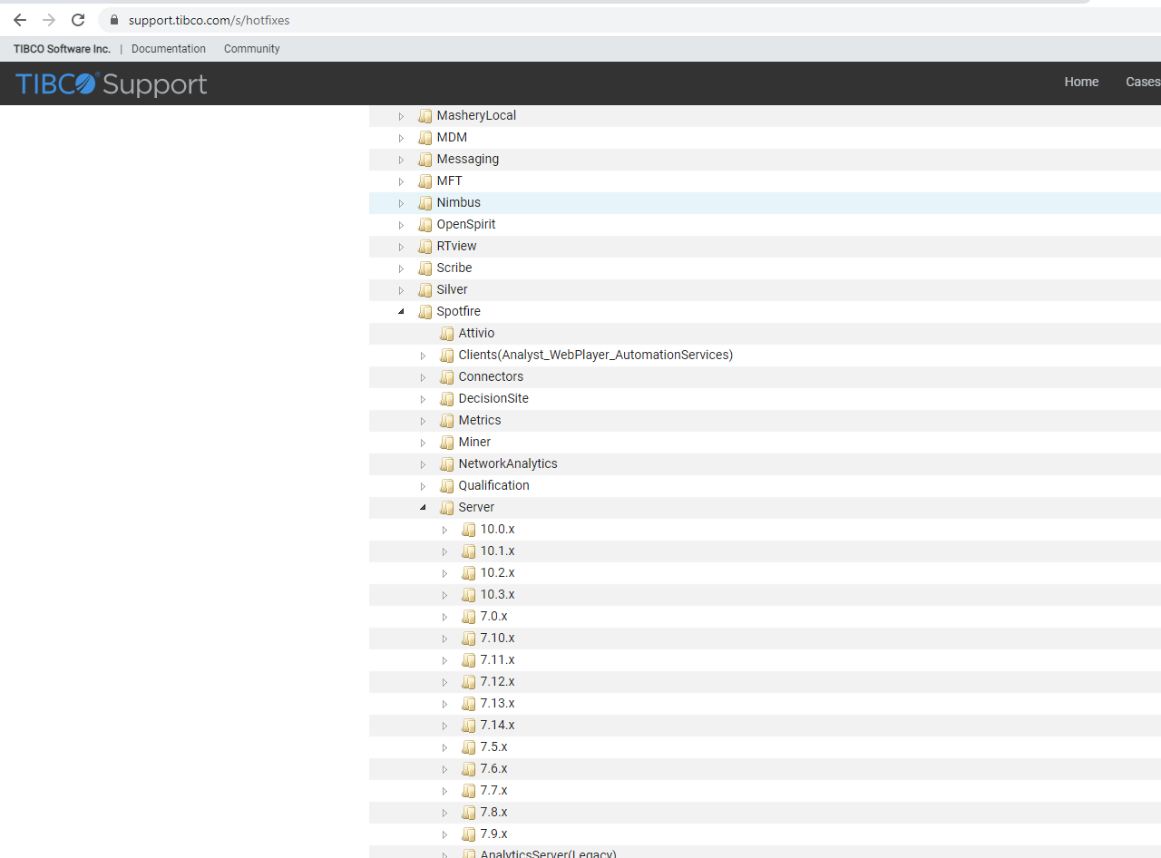

##### Download and Install SQL Developer:

SQL Developer software will be required to verify Spotfire metadata DB and Spotfire Oracle user setup

1. Download SQL Developer from Oracle website:

https://www.oracle.com/tools/downloads/sqldev-downloads.html

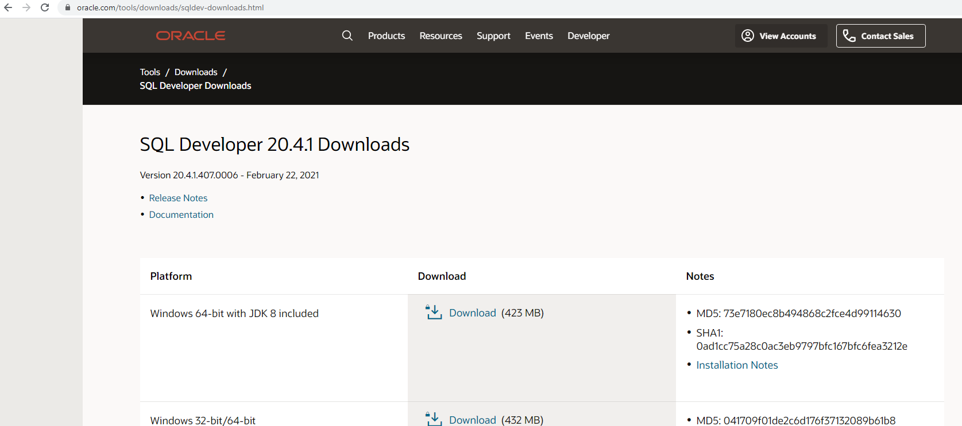

1. Verify the download is valid by running SQL Developer

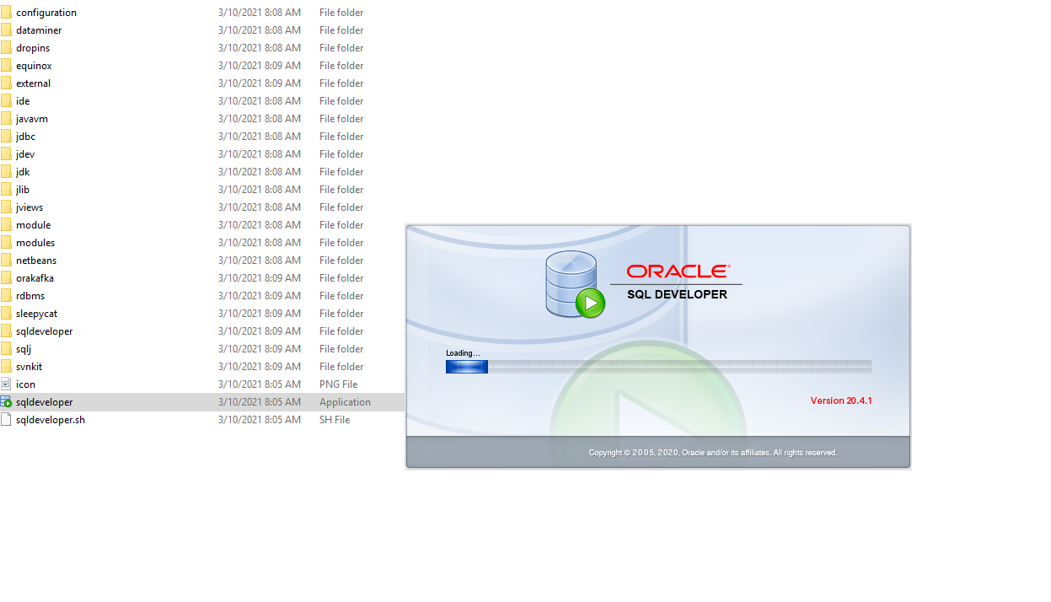

1. Test Connection to Spotfire Metadata Database:

***Database server Connection String:***

***Endpoint****:*

***Username****: devdbadmin*

***password****:*

***Port*** *:1521*

***SID*** *:*

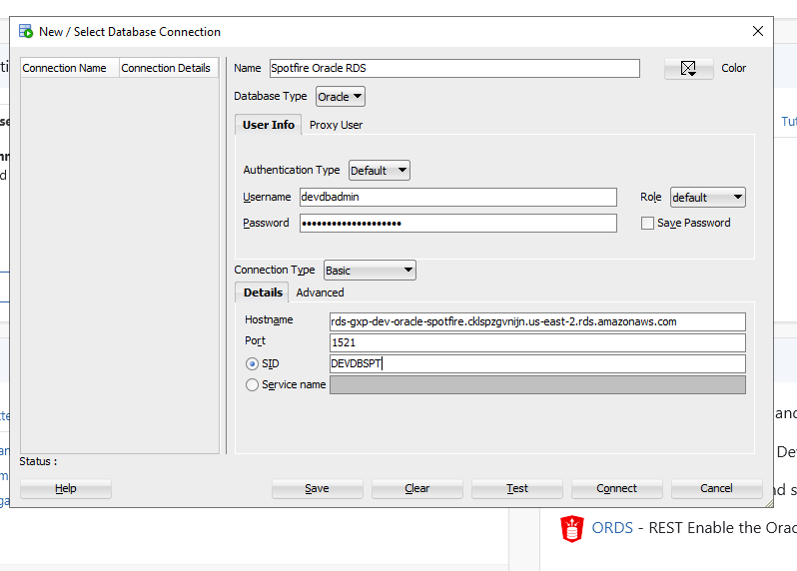

##### Download and Install SQLPLUS

SQLPLUS is required to run Spotfire metadata scripts via batch commands :

1. Download and install latest Visual C++ redistributable from below site:

<https://support.microsoft.com/en-us/topic/the-latest-supported-visual-c-downloads-2647da03-1eea-4433-9aff-95f26a218cc0>

1. Run the [vc_redist.x64.exe](https://aka.ms/vs/16/release/vc_redist.x64.exe) file finish the installation.
2. Create a new directory for the instant client. Create a new folder under C:\ or any other folder. This new folder will be used to store the oracle instant client files. In this case, I will create a new folder called C:\oracle
3. Download and install oracle sqlplus client

<https://www.oracle.com/database/technologies/instant-client/winx64-64-downloads.html>

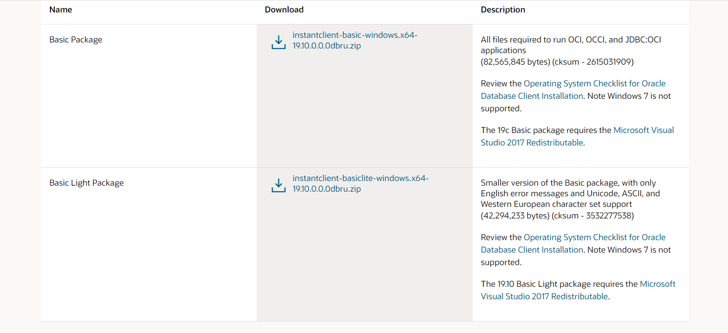

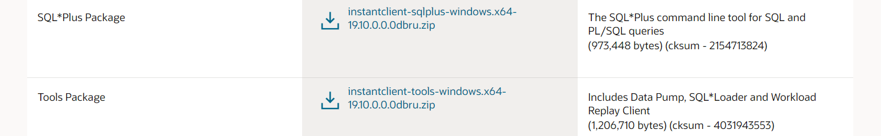

Download the basic package and SQLplus package and extract all files in C:\oracle

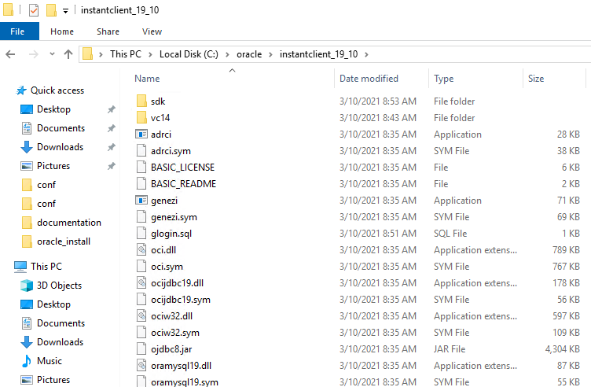

1. Modify environment variables as follows:

Create a new system variable called OCU_LIB64 and assign the following path

C:\oracle\instantclient_19_10

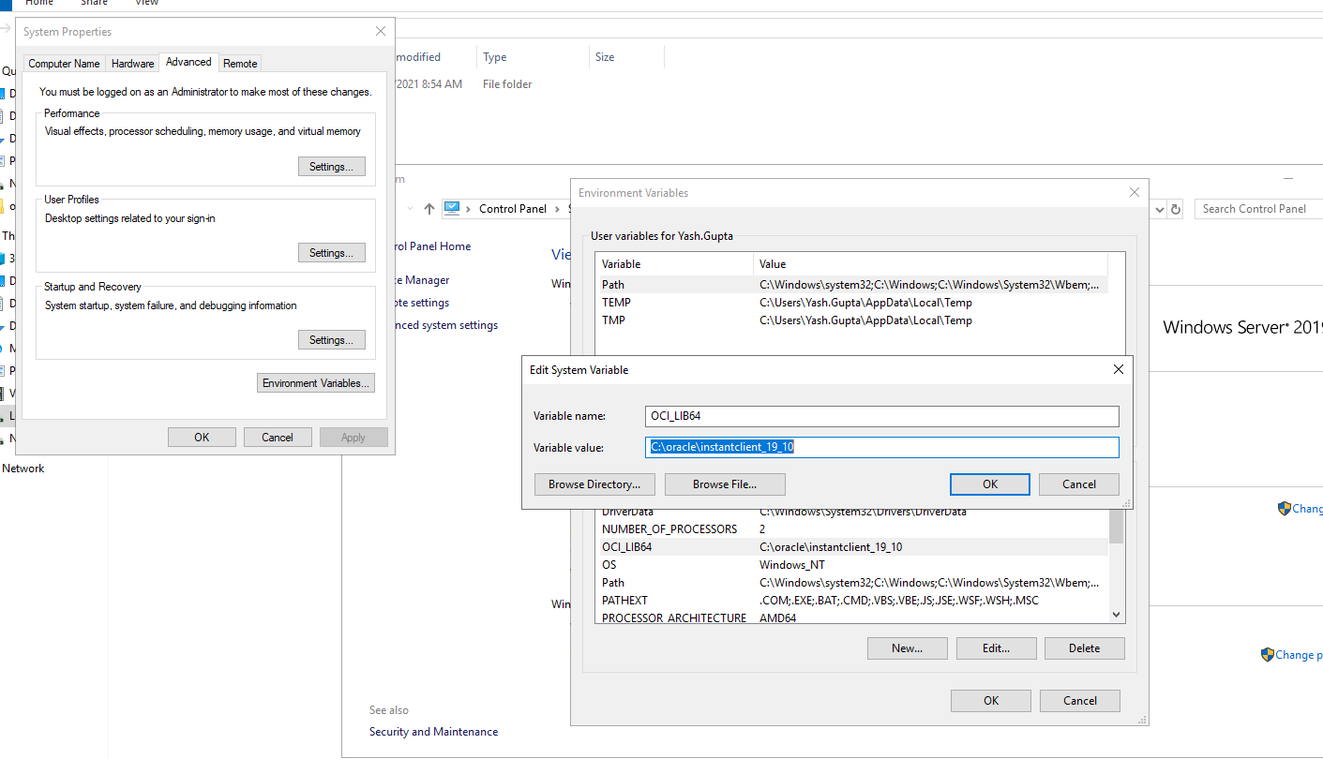

Add the “C:\oracle\instantclient_19_10” to user paths as well:

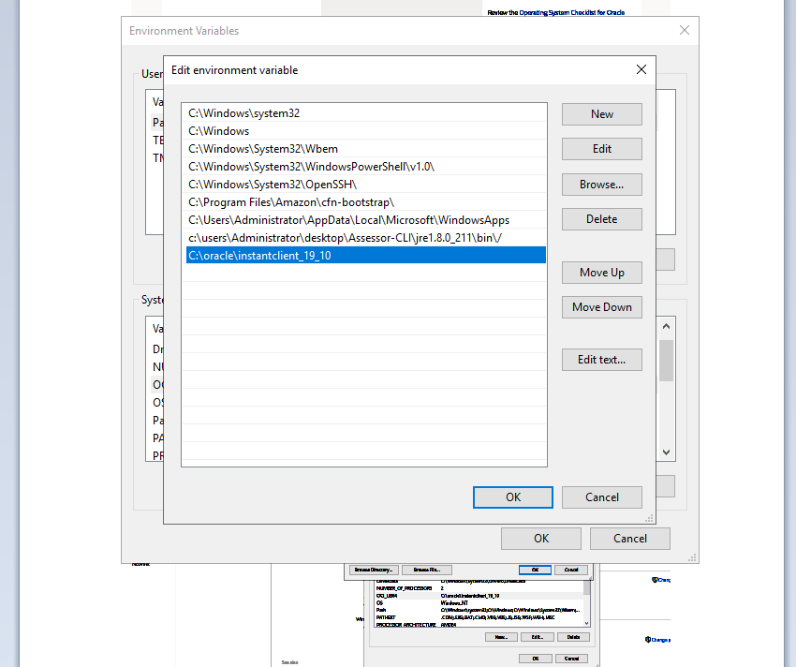

Once SQLPlus is ready, oracle scripts will be able to execute on the system. Test the same on command prompt by using the sqlplus command:

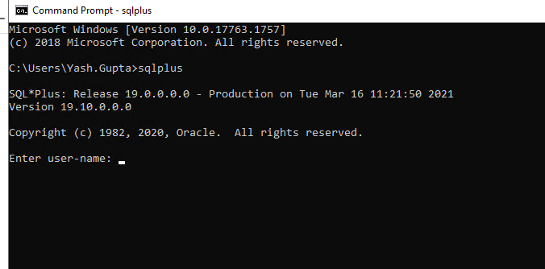

# Configuration Metadata DB

##### Configure and Run Oracle RDS Database Script

1. Go to oracle-install folder in Spotfire installation directory and edit “create_datbases_rds.bat” script as follows. Following parameters need to be set

* CONNECTIDENTIFIER
* ADMINNAME
* ADMINPASSWORD
* SERVERDB_USER
* SERVERDB_PASSWORD

Modify to:

CONNECTIDENTIFIER=db.com1521/DEVDBSPT

set ADMINNAME=devdbadmin

set ADMINPASSWORD=

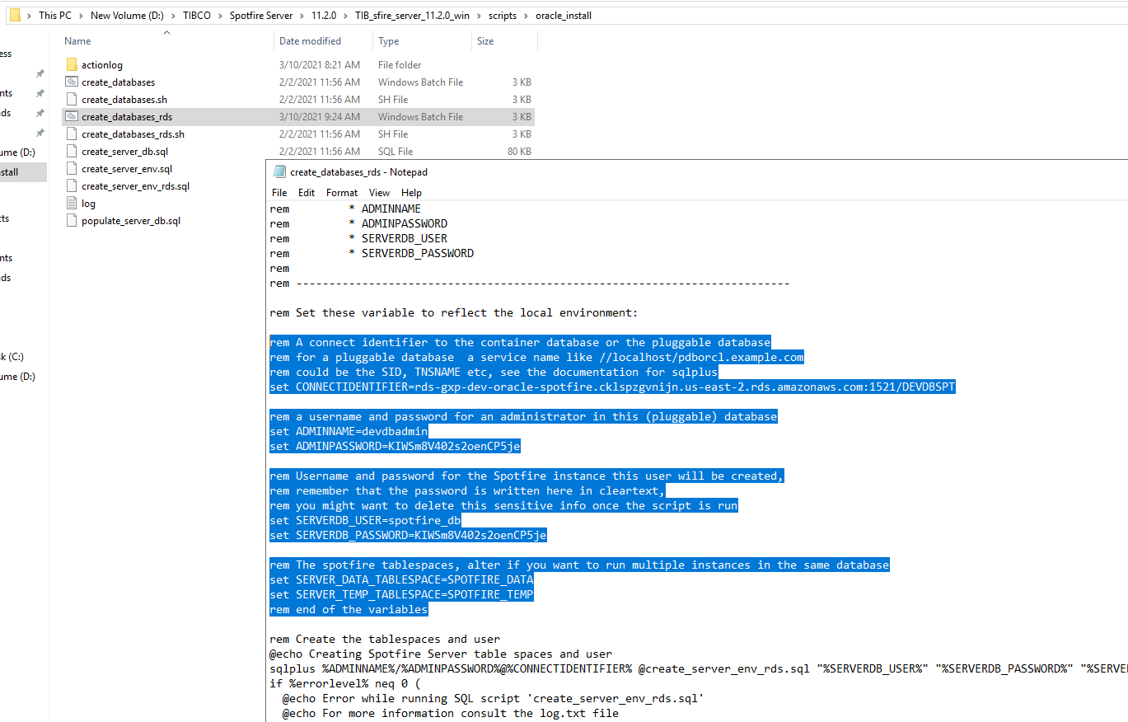

set SERVERDB_USER=spotfire_db

set SERVERDB_PASSWORD=

set SERVER_DATA_TABLESPACE=SPOTFIRE_DATA

set SERVER_TEMP_TABLESPACE=SPOTFIRE_TEMP

Save the file.

1. Go to command prompt, navigate to oracle_install folder in installation directory and run the create_databases_rds batch file:

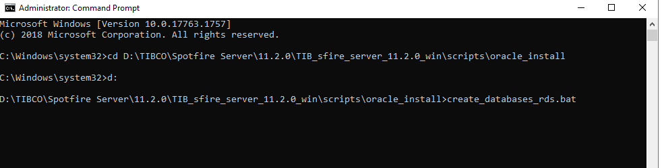

Once the script runs successfully, check the log file for any errors

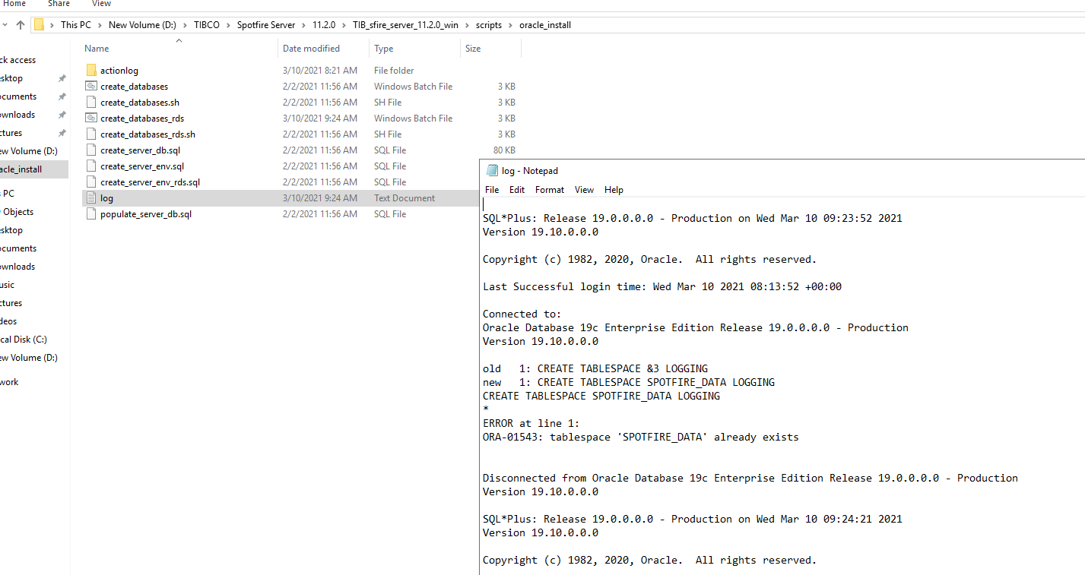

1. Verify the database and user creation through SQL developer:

As visible in below screenshot, spotfire_db is created and metadata tables are visible in the Oracle RDS database:

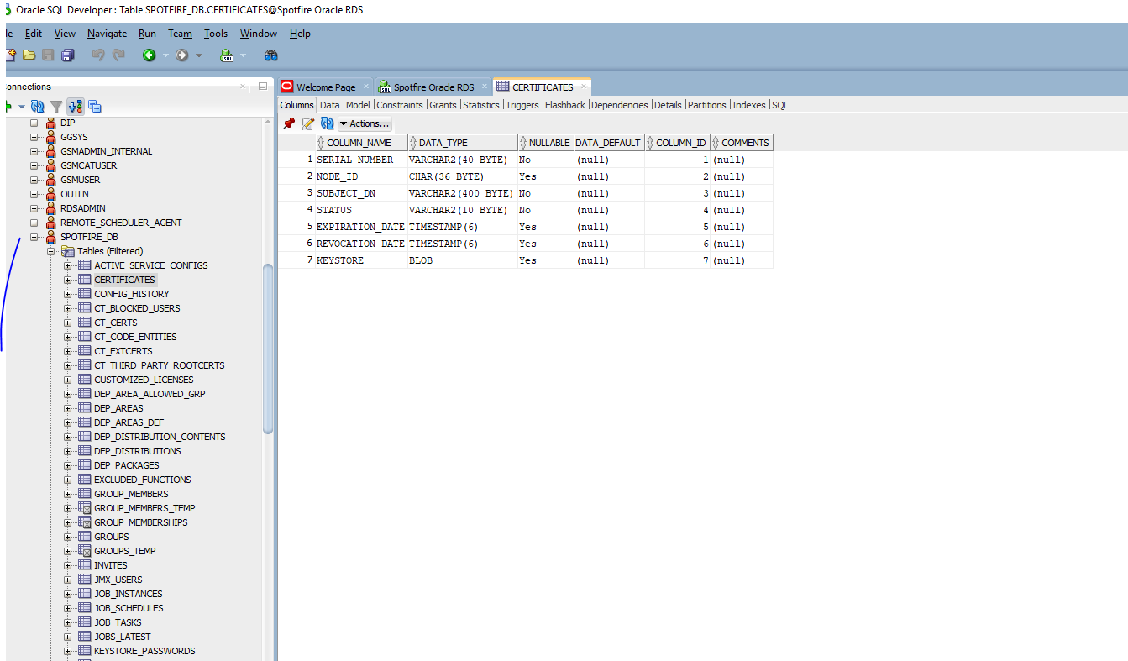

# Install Spotfire Server

Installing the Spotfire Server files (interactively on Windows)

1. In the server installation kit that you downloaded from the TIBCO eDelivery site, double-click

setup-win64.exe.

1. In the installation wizard Welcome dialog, click Next.

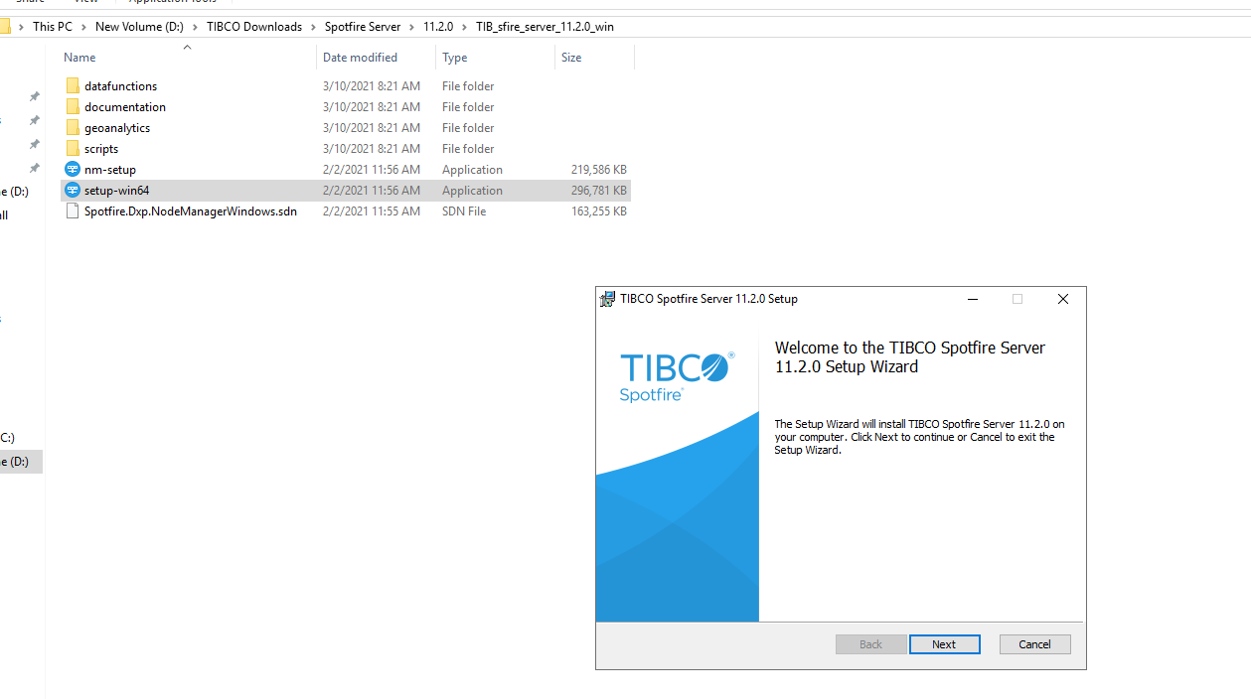

3. In the License dialog, read the agreement, accept the terms, and then click Next.

4. In the Destination Folder dialog you can change the location if you want to, and then click Next. In our case the installation directory is D:\tibco

5. In the Windows Service dialog, select the option you want and then click Next.

6. In the Spotfire Server Port dialog you can specify the front-end port, and then click Next.

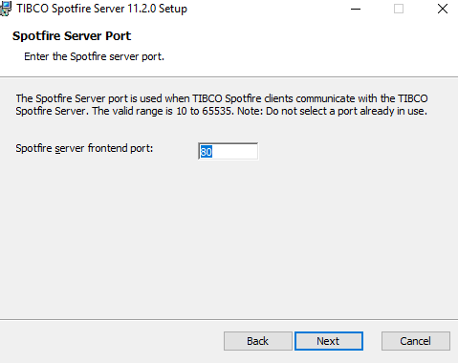

To check whether a port is in use, open a command prompt, type netstat -na, and press

Enter.

The ports selected during installation for front-end, back-end communication, and back-end

registration ports must be open in the firewall. (The defaults are 80, 9443, and 9080.)

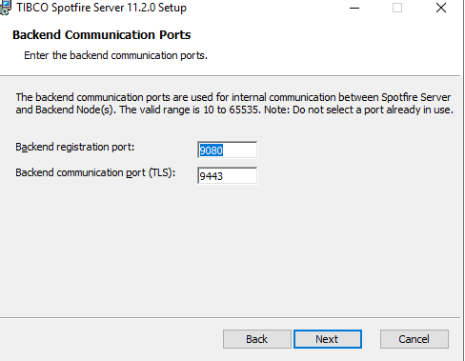

7. In the Backend Communication Ports dialog you can specify the back-end ports, and then click

Next.

8. In the Ready to Install dialog, click Install.

The Installing dialog tracks the progress of the installation.

9. When the installation is completed, select Launch the configuration tool to open the configuration

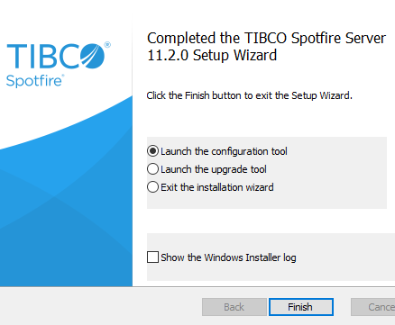

tool, or Launch the upgrade tool if you are upgrading. In our case, no upgrade is required.

1. To create a connection between Spotfire server and oracle database, we need to download oracle drivers from website

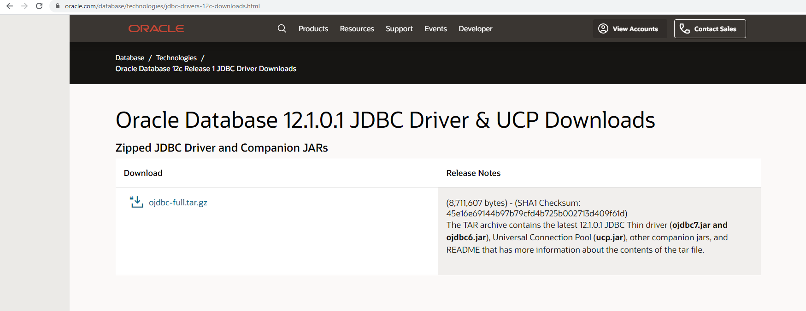

Place the ODBC jar file t below location

<installation dir>/tomcat/custom-ext

D:\tibco\tss\11.2.0\tomcat\custom-ext

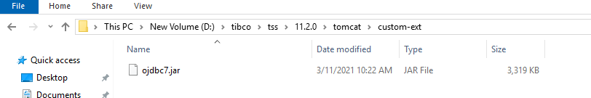

# Spotfire Configuration

Got to Configuration Tool. There will be multiple sections marked with red X. We need to configure each section one by one and change the status to green.

1. Configure the bootstrap file. Click on “Create new bootstrap file” under “Connect to Database”

***hostname****: db.com*

***port****: 1521*

***Sid****:*

***Username*** *; spotfire_db*

***Password****:*

***Confgi Tool password****:*

***Encryption Password*** *:*

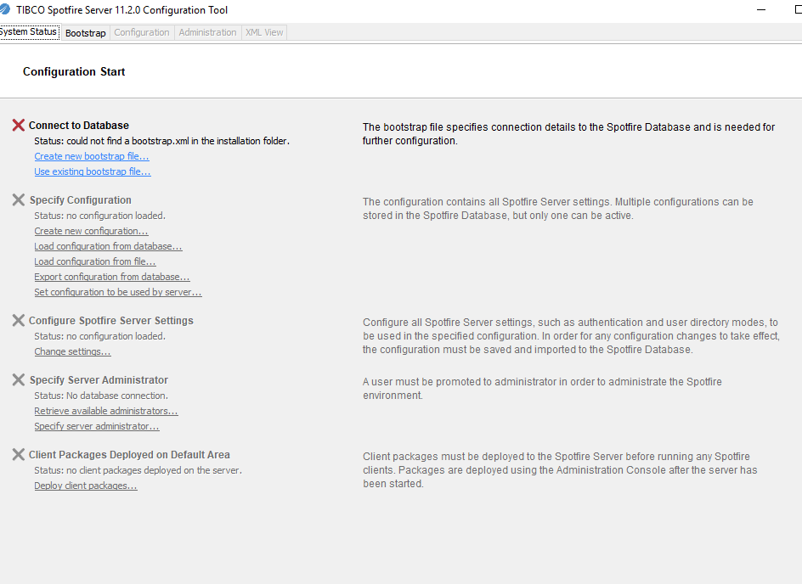

Once the bootstrap is created, you'll see the green status on config tool like below:

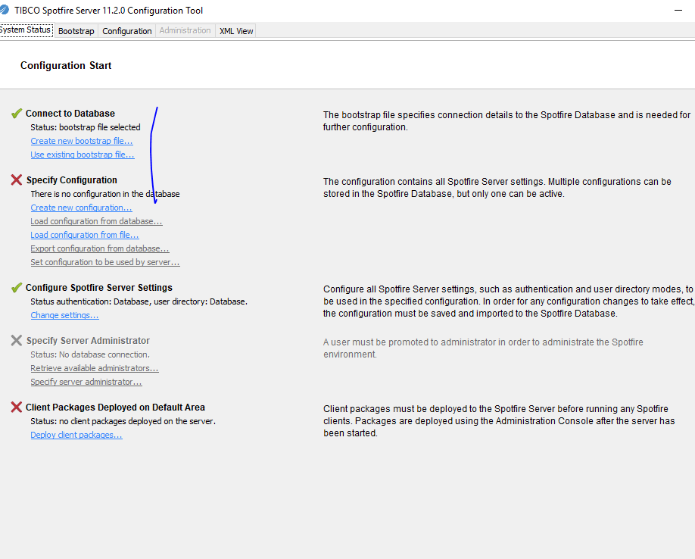

1. Create an initial configuration with basic authentication. Initially a simple configuration will be created for Spotfire server which can later be modified as per requirement.

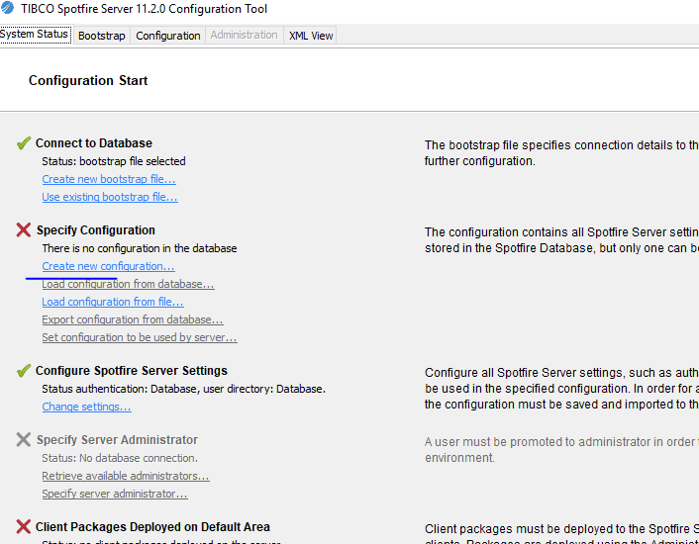

Verify all the fields are filled and entries are valid. Refer to TIBCO installation and configuration reference for more details on initial configuration

Save to database, all configurations reside in metadata database. Saving to file will not activate the configuration changes.

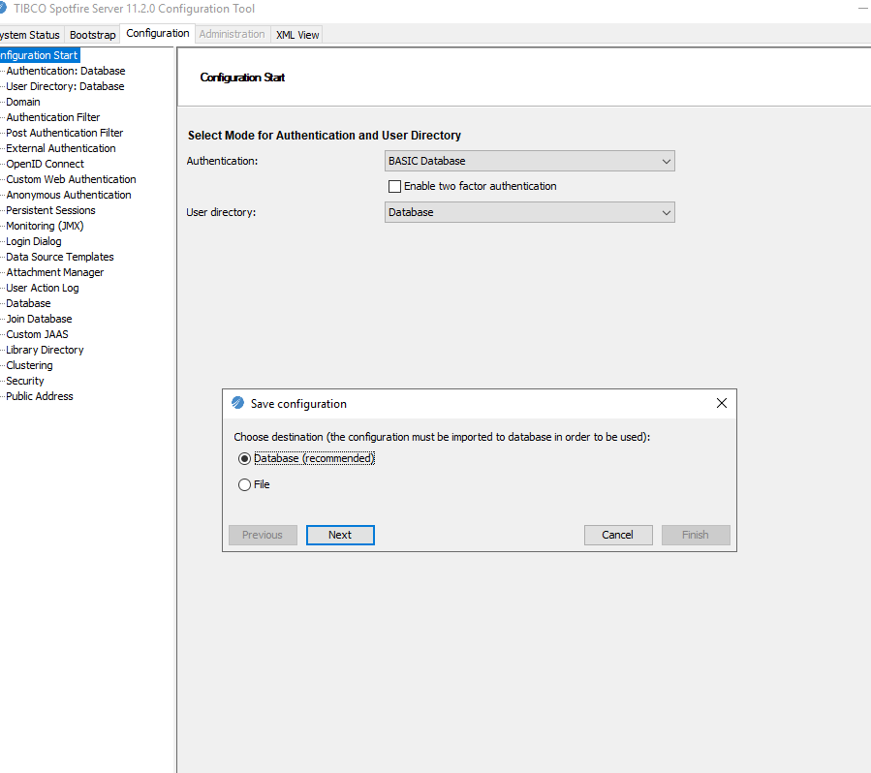

Post this step, go back to “System status” screen and check the status of recent configurations:

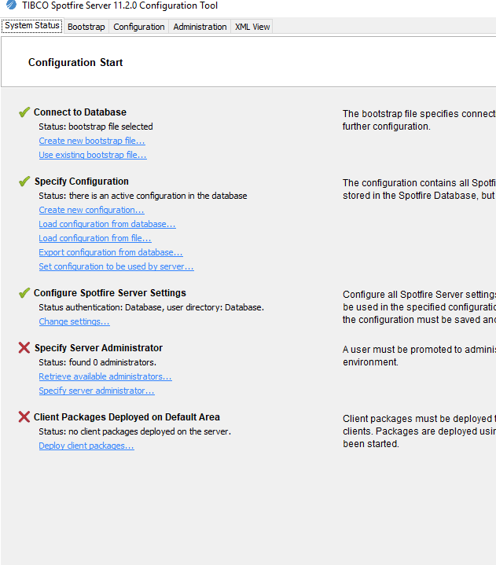

1. Go to Administration tab in config tool and create new user:

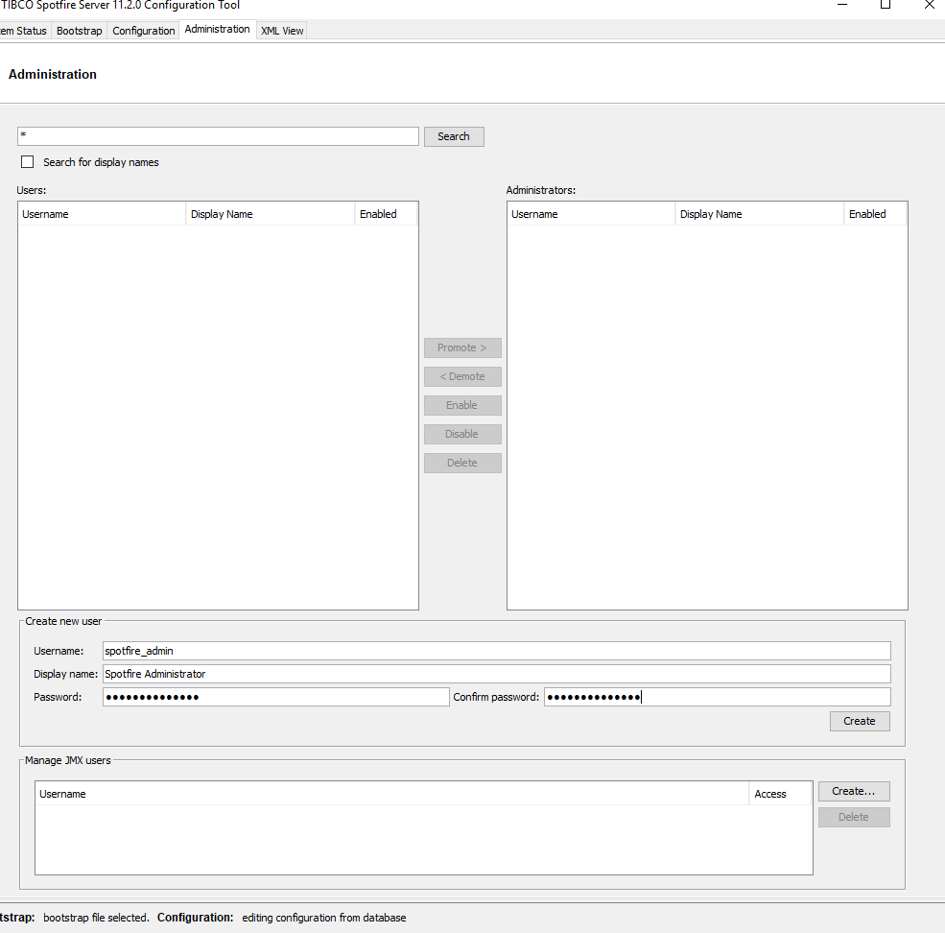

*user: spotfire_admin*

*password spotfire_admin*

and promote the same to admin as specified in below screenshot

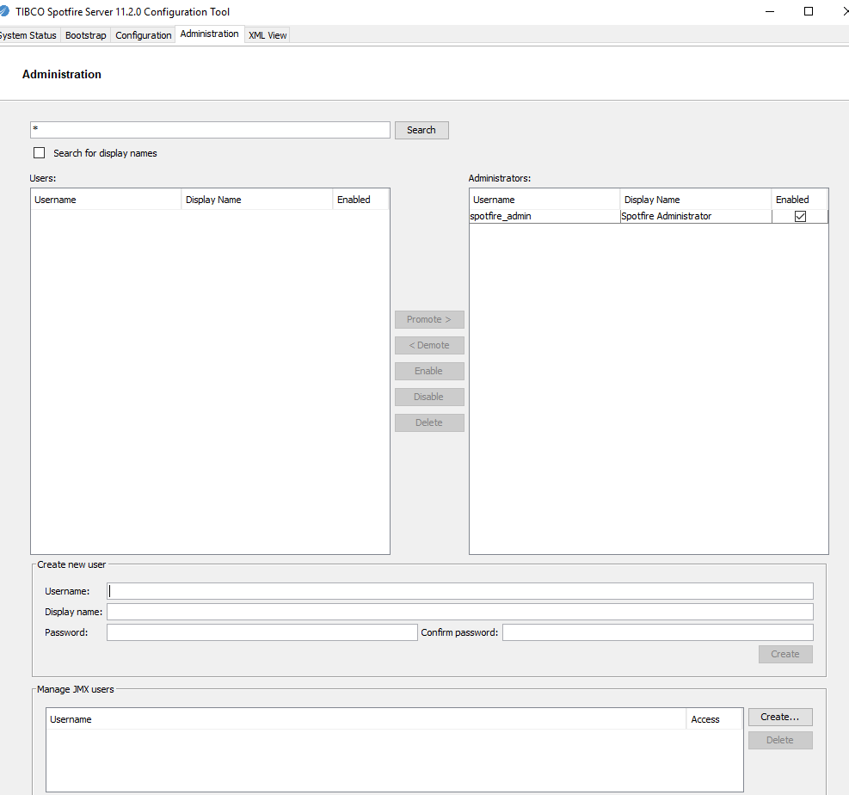

Go back to the system status tab and the status will be updated on config tool

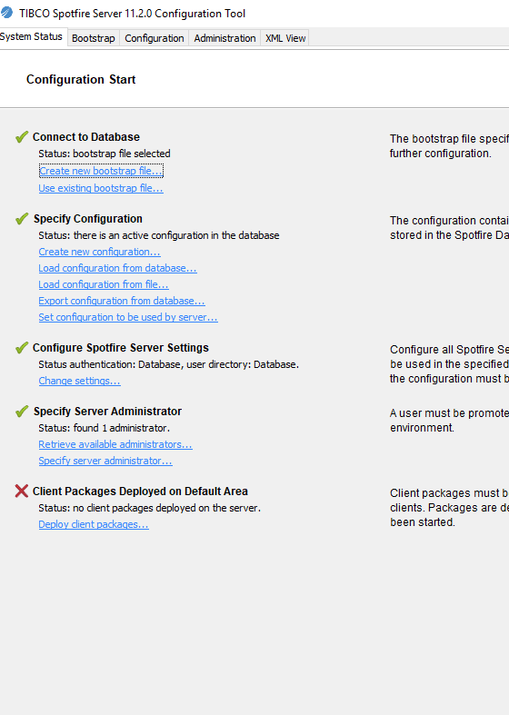

1. To install and use the Spotfire Analyst client and Spotfire web client, you must first deploy the Spotfire.Dxp.sdn distribution file to the server. This package is required for licenses to appear in the administration interface.

* On the System Status page of the configuration tool, at the bottom of the list, click Deploy client packages.
* In the Deploy Client Packages dialog, click Browse, and then locate and double-click the Spotfire.Dxp.sdn file. The file will be at below location:

D:\TIBCO Downloads\Spotfire Server\11.2.0\TIB_sfire_deploy_11.2.0\Products\TIBCO Spotfire Distribution

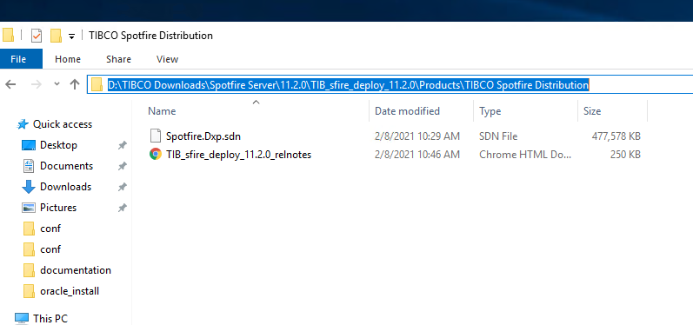

* Click Deploy

Configuration status will be all green

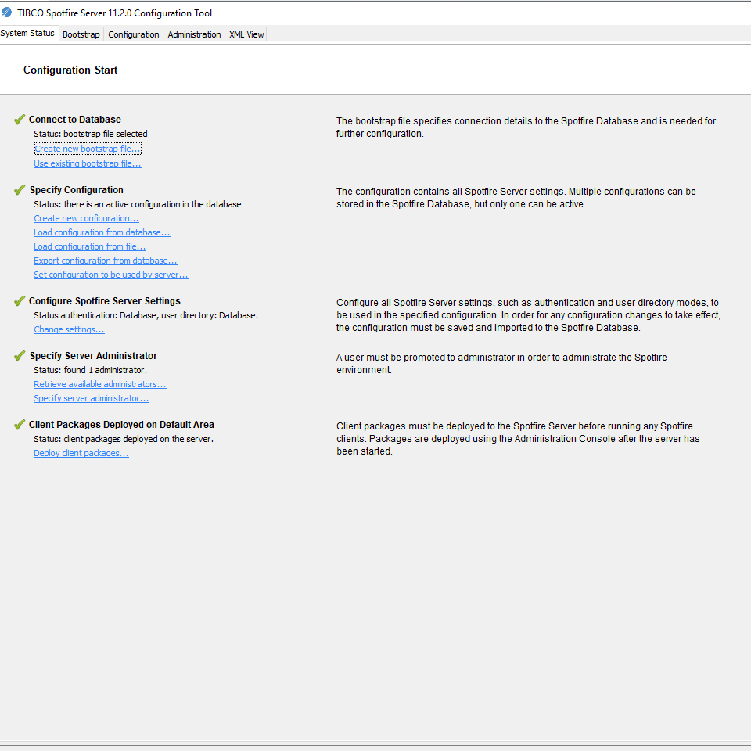

# Node manager installation

To be able to run services, you must first install and trust one or several node managers, depending on

the expected workload.

- Start spotfire service: Go to servces.msc, search for TIBCO Spotfire server service and start the same:

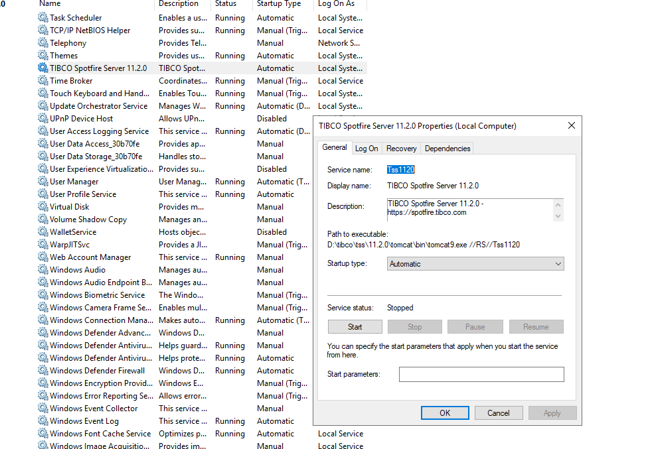

##### Run Node Manager setup

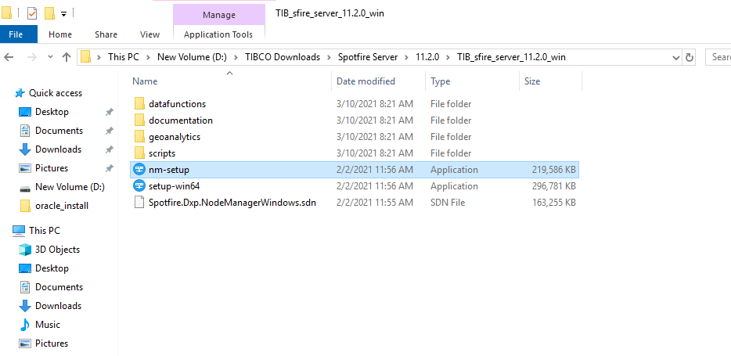

1. Double-click nm-setup.exe.

2. On the installation wizard Welcome page, click Next.

3. On the License page, read the agreement, select I accept, and then click Next.

4. On the Destination Folder page you can change the location if you want to, and then click Next.

5. On the Node Manager Ports page, enter numbers (or leave the defaults) for the following ports:

● Node Manager registration port—The port that is used to set up secure internal communication

channels. 9081

● Node Manager communication port (TLS)—The port that is used for secure (TLS)

communication within the implementation. 9444

The selected ports must be available and not blocked by a firewall.

To check whether a port is in use, on a command line enter netstat -na.

6. Click Next.

The Spotfire Server page opens.

7. On the Spotfire Server page, enter the following information, and then click Next.

These values must match the values you used when installing the Spotfire Server files.

● Server name—The hostname of Spotfire Server.

Valid hostnames can only contain alphabetic characters, numeric characters, hyphens,

and periods.

● Server backend registration port—The registration port that you specified during Spotfire

Server installation.

● Server backend communication port (TLS)—The backend communication port that you

specified during Spotfire Server installation.

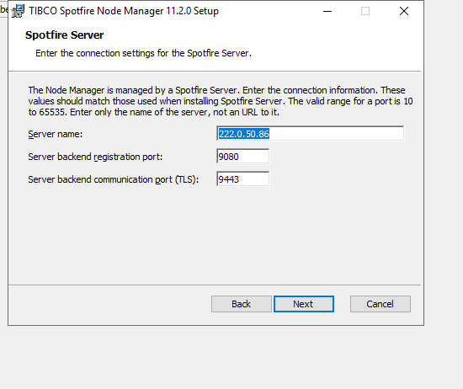

8. On the Network Names page, select the computer names that can be used by backend trust. In

general you can leave all the listed names as they are.

9. On the Ready to Install page, click Install.

10. Click Finish when done.

Start the node manager service

Go to services> Sleect TIBCO Node Mnager > Start

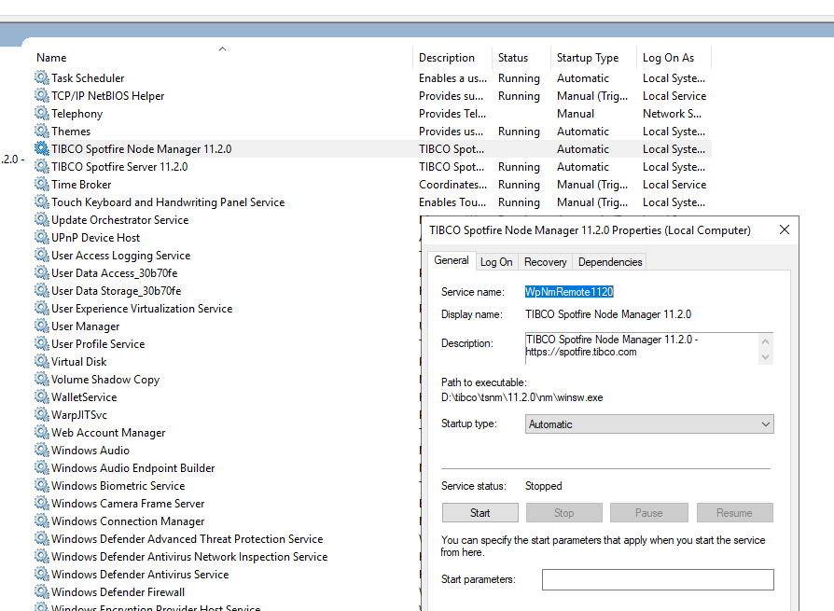

##### Trusting a node

After installing the node manager, you must indicate in Spotfire Server that you trust the node.

1. Log in to Spotfire Server. (For instructions on accessing the server, see Opening Spotfire Server.)

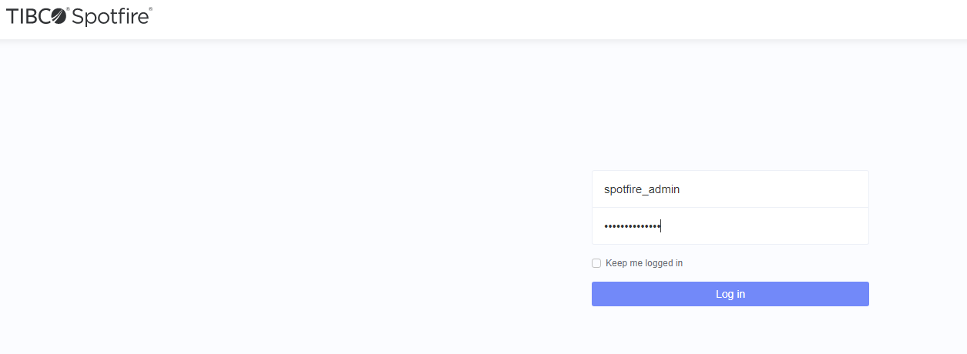

2. Click Nodes & Services, and then click the Untrusted nodes tab.

3. Under Untrusted nodes, select the check box next to the new node manager and then click Trust nodes.

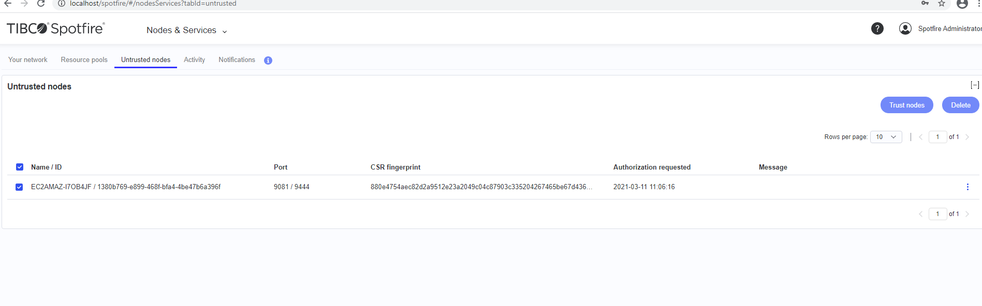

4. In the "Trust node" dialog, click Trust.

Result

After a pause, the new node appears on the Your network page when you select the Nodes vie

##### Installing Spotfire Web Player instances

1. Log in to Spotfire Server and click Nodes & Services.

2. Under Select a view, select Nodes, and then select the node to which you want to add the Spotfire

Web Player service. There should be a green circle with a check mark next to the selected node.

3. In the lower-right pane, click Install new service.

4. Make your selections in the "Install new service" dialog:

a) Under Deployment area, select the area you are using.

b) Under Capability, select Web Player.

c) Under Configuration, select the service configuration that you want to apply to the service.

Spotfire Server contains a default service configuration that you can replace later. If

you want to prepare a configuration file ahead of time, see Preconfiguring Spotfire Web

Player services.

d) Under Number of instances, enter the number of instances of the service that you want to

make available. For more information, see Multiple service instances on one node.

e) Under Port, you can change the default of 9501 if you want to.

f) Enter a name for this service

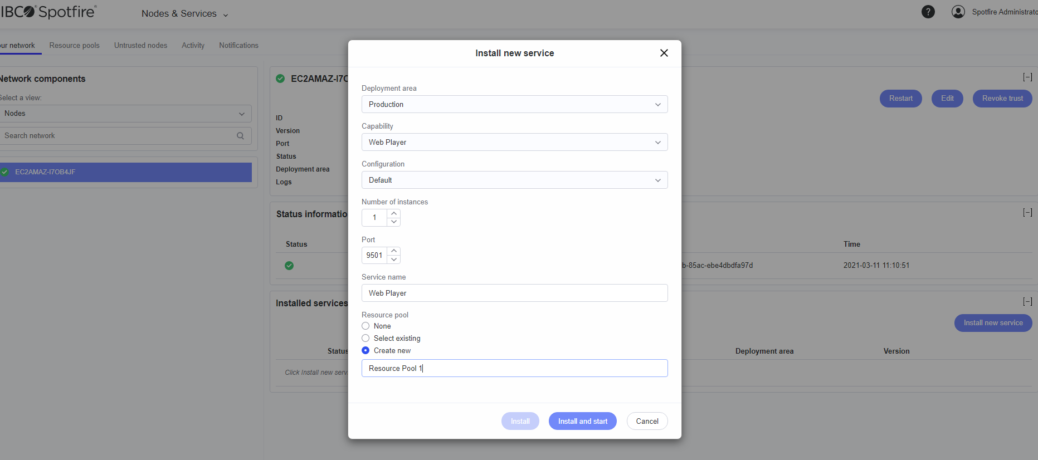

##### Installing Spotfire Automation Services

1. Log in to Spotfire Server and click Nodes & Services.

2. In the Nodes view, select the node to which you want to add the Spotfire Automation Services

service. There should be a green circle with a check mark next to the selected node manager.

The words Installed services followed by the name of the node manager are displayed in the lowerright pane of the window.

3. Click Install new service.

4. Make your selections in the "Install new service" dialog:

a) Under Deployment area, select the area you are using.

b) Under Capability select Automation Services.

c) Under Configuration, select the service configuration that you want to apply to the service.

Spotfire Server contains a default service configuration that you can replace later. d) Under Number of instances, enter the number of instances of the service that you want to

make available.

e) Under Port, you can change the default of 9502

f) Enter a name for this service.

5. Click Install and start.

To view the progress of the installation, click the Activity tab.

##### Installing TERR and Python Service

- Extract installation files from TERR downloads

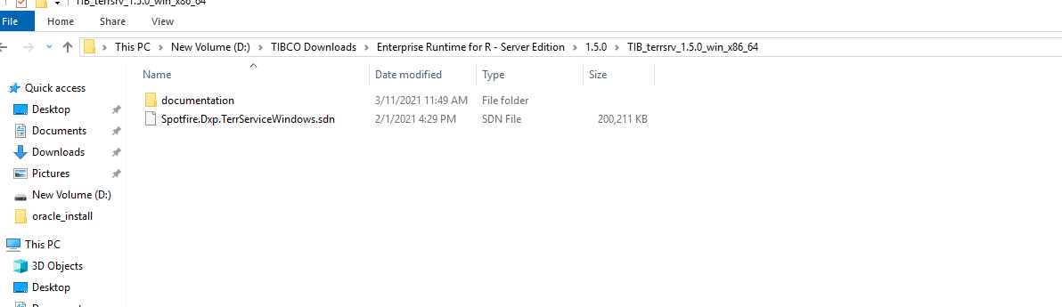

-Deploy the package

Deployment--> Add package--> select terr sdn

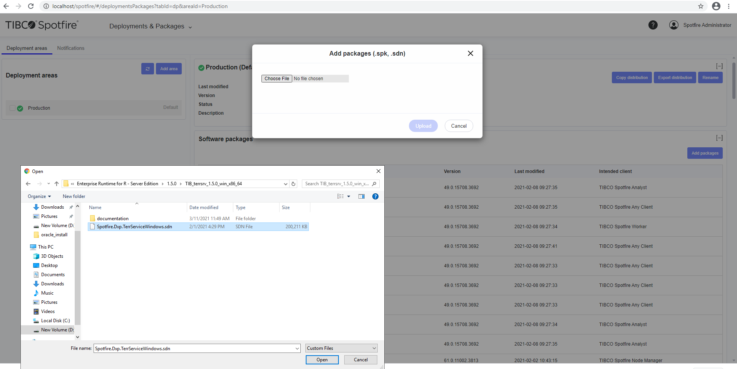

- Extract Python service files

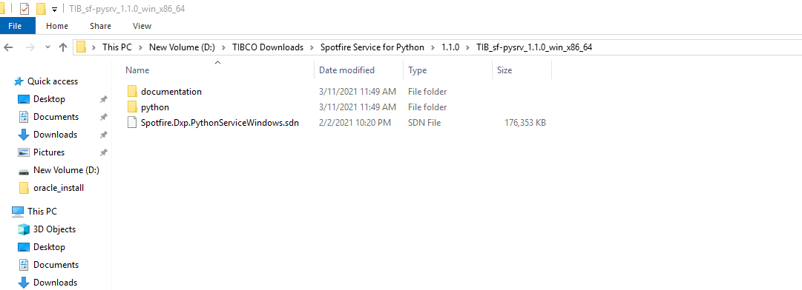

Deploy

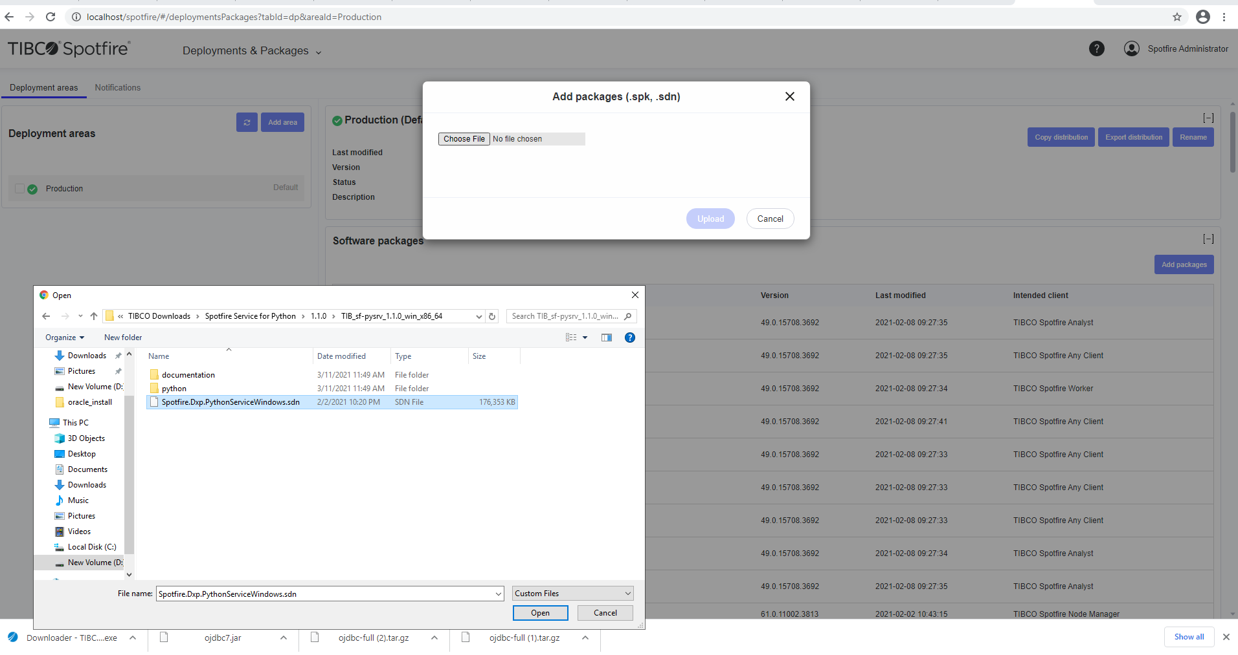

Install TERR Service on 9503

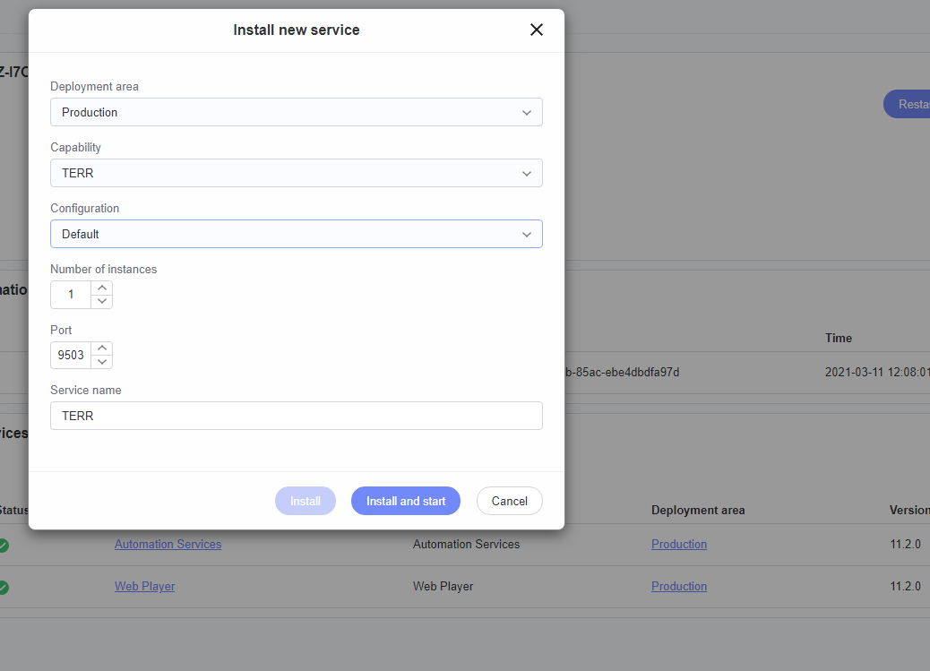

Install Python Service : 9504

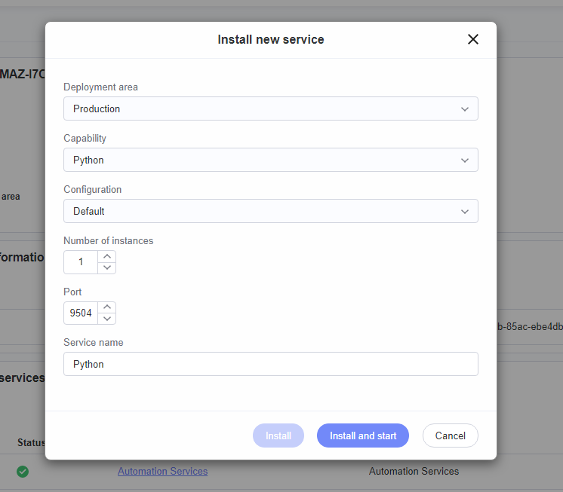

##### Installing Spotfire Analyst

* 1. Install Spotfire Analyst either interactively, by running the setup-shared-computer-

<version>.exe file,

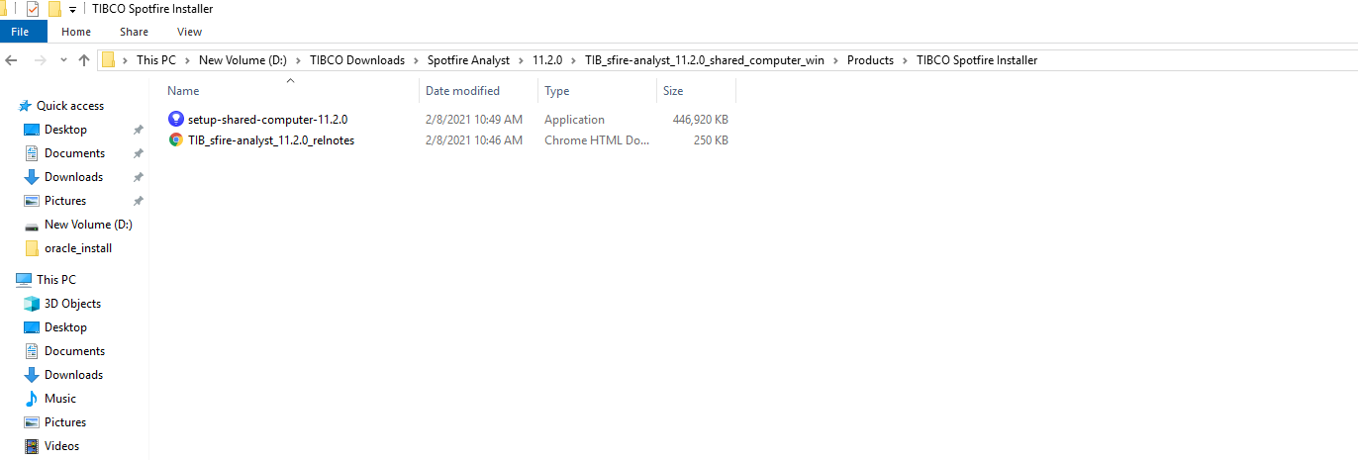

* 1. Login to Spotfire server using admin credentials:

# Additional TERR Configuration

TERR server is default configured to ask for trust on scripts and run the same in restricted execution mode. Configure TERR to automatically trust scripts and ignore execution in restricted mode:

1. Open cmd in Admin mode

Go to D:\tibco\tss\11.2.0\tomcat\spotfire-bin

1. Run the following command

config export-service-config --capability=TERR --deployment-area=PRODUCTION

1. Make changes to exported config files:

# Use TERR restricted execution mode, TRUE or FALSE

**terr.restricted.execution.mode: FALSE**

# When true, the service does not query the server for the Data Function Trust.

**disable.spotfire.trust.checks=True**

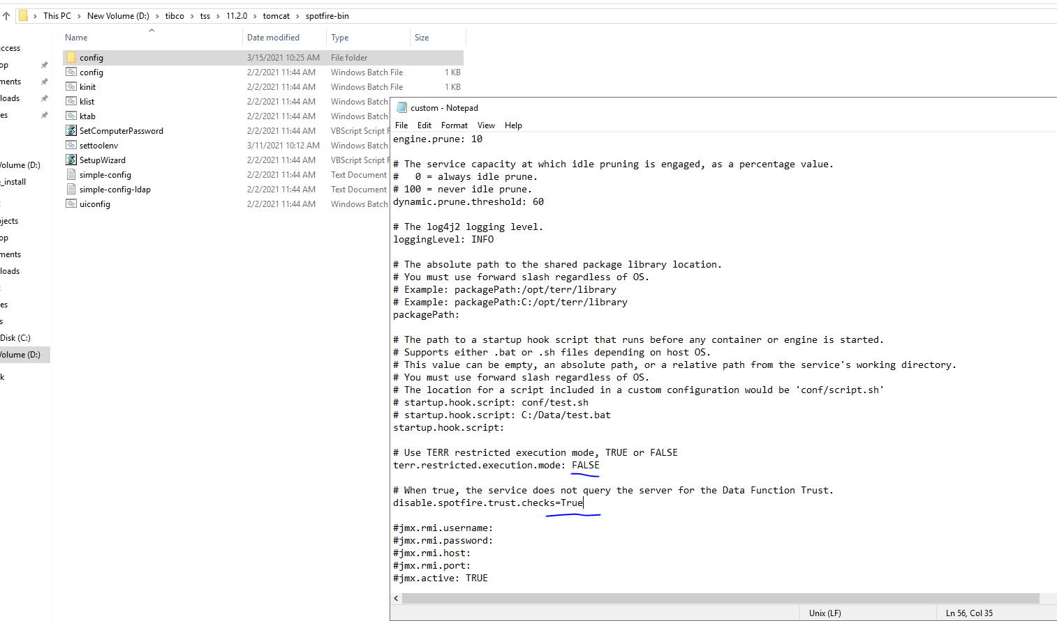

1. Import the configuration back to server

config import-service-config --config-name=change_trust_restricted_mode

1. Go to node manager and activate the recently modified configuration

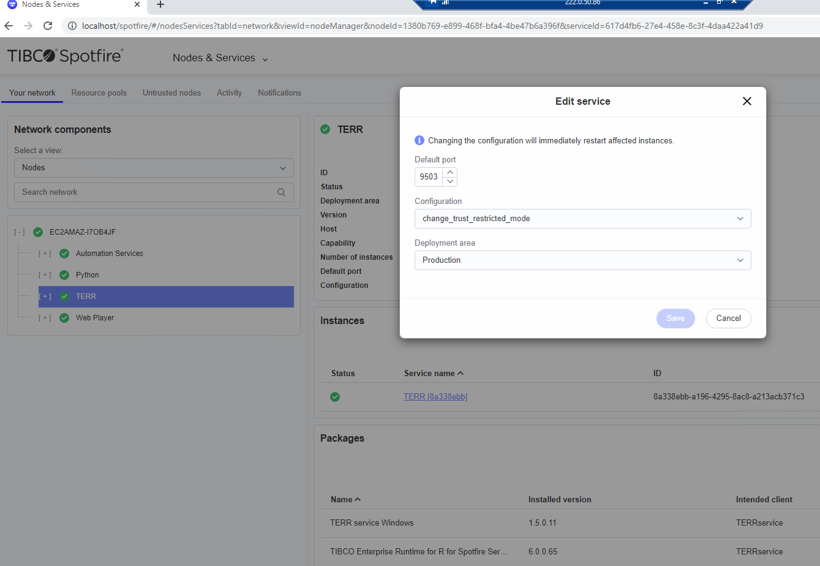

1. Restart the node manager.

# Setup Snowflake Datasource

1. Download Snowflake driver from below location

<https://docs.snowflake.com/en/user-guide/odbc-windows.html>

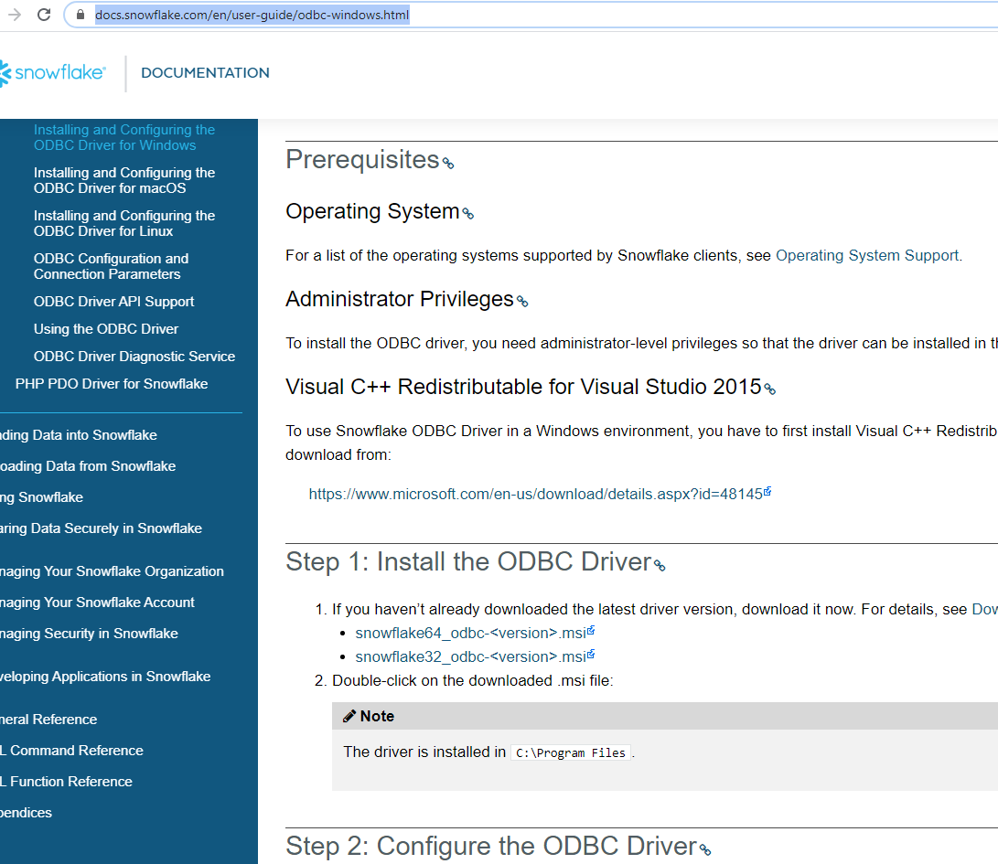

Configure The driver - Go to System data sources and verify the installation;

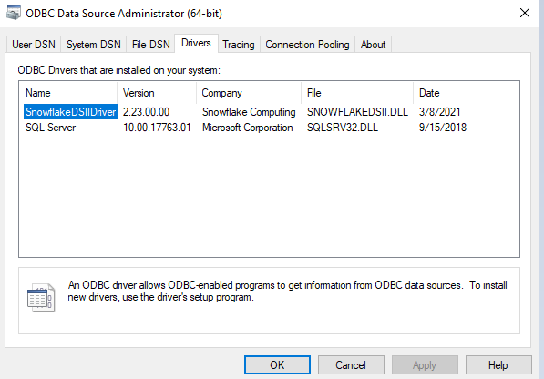

Post this step Snowflake DSN’s can be created to support working with Spotfire snowflake connector.

For snowflake datasource setup via Information Designer:

1. Download Snowfalke JDBC driver from following website:

[https://docs.snowflake.com/en/user-guide/jdbc-download.html#downloading-the-driver](https://docs.snowflake.com/en/user-guide/jdbc-download.html" \l "downloading-the-driver)

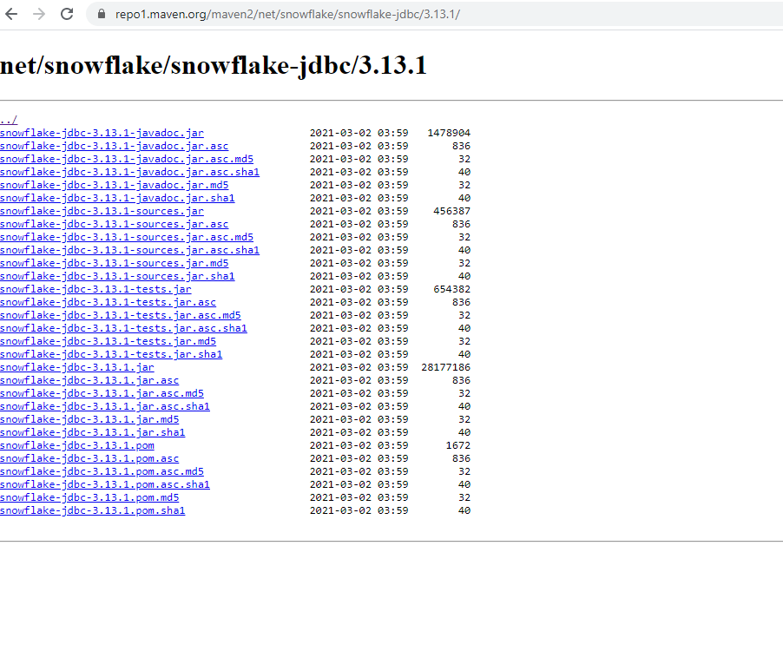

1. Download the latest version and place it in installation folder

D:\tibco\tss\11.2.0\tomcat\custom-ext

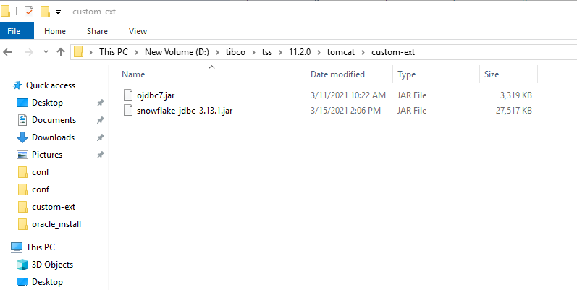

1. Open Spotfire config tool and create a new datasource template for snowflake

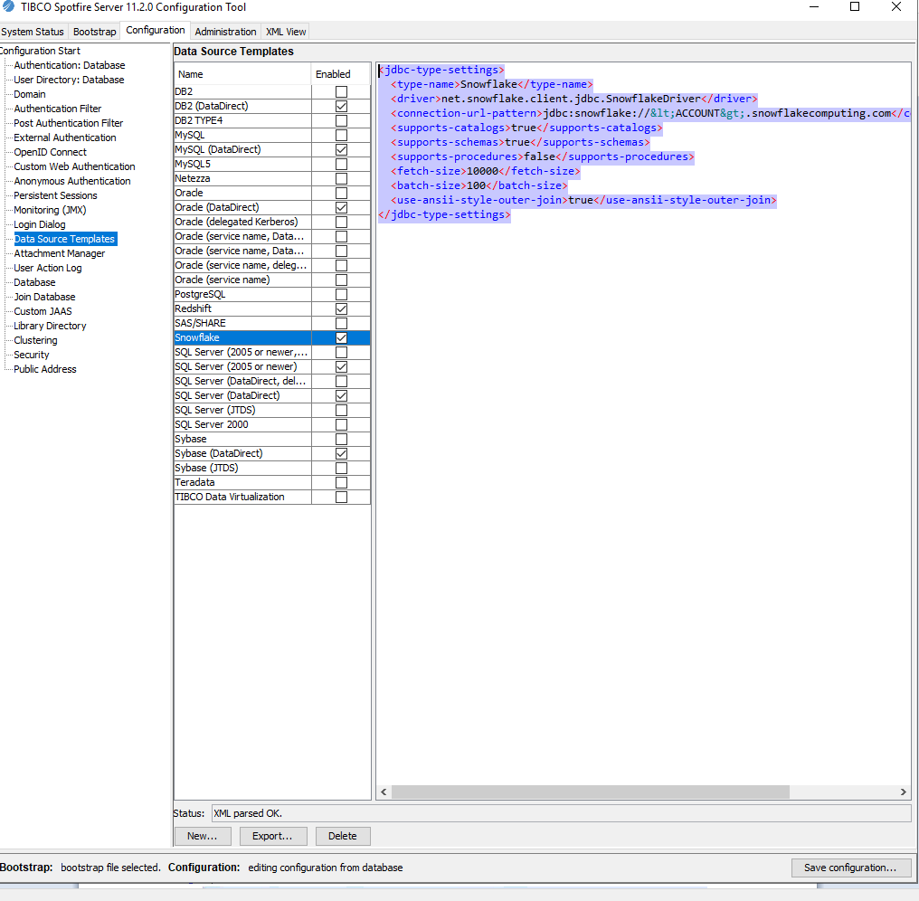

*<jdbc-type-settings>*

*<type-name>Snowflake</type-name>*

*<driver>net.snowflake.client.jdbc.SnowflakeDriver</driver>*

*<connection-url-pattern>jdbc:snowflake://&lt;ACCOUNT&gt;.snowflakecomputing.com</connection-url-pattern>*

*<supports-catalogs>true</supports-catalogs>*

*<supports-schemas>true</supports-schemas>*

*<supports-procedures>false</supports-procedures>*

*<fetch-size>10000</fetch-size>*

*<batch-size>100</batch-size>*

*<use-ansii-style-outer-join>true</use-ansii-style-outer-join>*

*</jdbc-type-settings>*

1. Click on save configuration
2. Restart Spotfire Services

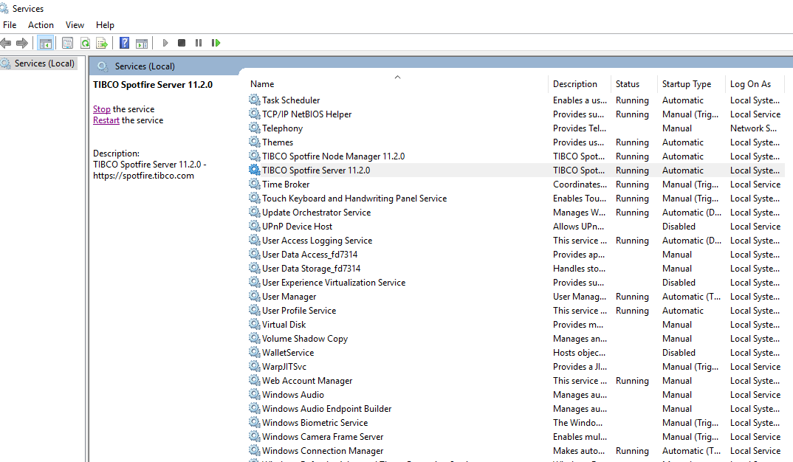

1. Login through Spotfire analyst after restart, open information designer and create a sample snowflake data connection to verify the data source:

